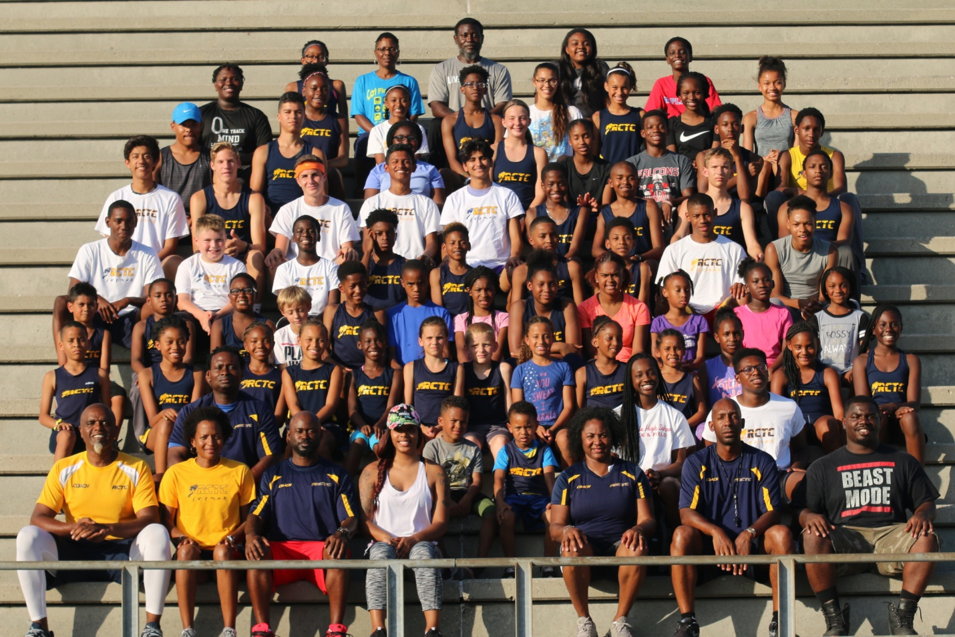
Rutherford County Track Club (“RCTC”) closed out another fantastic outdoor season by attending the AAU Junior Olympics in Detroit, Michigan July 31st – August 5th, 2017. This outdoor season the team consisted of 85 athletes and had we had 52 athletes qualified for the AAU Junior Olympic Games and 10 athletes qualifies for the USATF Junior Olympic Championships.
We had 29 Athletes competing in 57 events and 2 relays at the AAU Junior Olympics games. We had 13 personal records (“PR”) with 5 All American and 1 NATIONAL CHAMPION/ Our All-Americans are. Roland McGhee(2), Aaron Green, Tanalya Gordon, and Sania McGhee
The team got the week started on Monday
Day 1 Recap Monday July 31.
We started of the morning with a BANG. Cyera Gordon took to the skies, she was our 1st ALL-AMERICAN of the games, and she was 2nd in the long jump with a leap of 18-2.50. Then we moved to the distance races with the 800m; Naiden Maynard 2:21.98(PR)(41th), McKenzie Louis 2:40.13(63rd), Michael Bass 2:23.23 (63rd), Robbie Polidan 2:30.41(73rd), and Casey Clementz 1:57.73(PR)(16th). We finished up the day with the 100m sprints with Meraiah Sublett 15.22 (36th), Ryan Moore 14.64 (52nd), Malachi Gordon 14.42(53rd), Haran Bass 14.24 (50th), Angel Martin 14.47(71st), Nigel Maynard 14.37(56th) Jabari Gordon 13.93(72nd), Aaron Green 12.82 (27th), Jorden Barnes 13.08(63rd), Valasha Watson 12.27 (qualified to the SEMI-FINALS), and Cyera Gordon 12.56(43rd). Congratulation to all.
Day 2 recap Aug 1st
We started the morning off in the field events with the Shot put; Sania McGhee(10yr old) threw her way into ALL-AMERICAN status placing 8th in the Shot Put 24-05. Next we moved onto the distance races with the 1500m; Maja Lakes 5:47.58(51st), McKenzie Louis 5:56.87 (57th), Robbie Polidan 5:18.23(69th), Brooke Rieves 5:42.06(40th), Andrew Nau 4:27.52(PR)(34th), and Casey Clementz 4:10.79(PR)(10th). Then the sprints races were next beginning with the 200m; Ryan Moore 30.40 (54th), Malachi Gordon 29.55(58th), Haran Bass 29.07(44th), Angel Martin 29.01(55th), Nigel Maynard 28.83(54th), Aaron Green 26.34 (34th), Roland McGhee Jr 23.87(PR)(qualified to the SEMI-FINALS), Valasha Watson 25.16(qualified to the SEMI-FINALS), and Cyera Gordon 25.46(47th). We finished up the running events with the 400m with Emma Lakes 1:15.24(60th), Malachi Gordon 1:10.00(PR)(52nd), Haran Bass 1:06.13(27th), Taylin Segree 1:04.30(33rd), and (Angel Martin 1:05.35(PR)(39th). We saved the best for last with the long jump, RCTC welcome the 2017 AAU NATIONAL CHAMPION 13yr old long jump, Roland McGhee Jr ALL-AMERICAN jumped his way to 1st place with a leap of 19-09.50. Congratulation again to all.
Day 3 Recap Aug 2nd
We started off with the field events with Trey'Von Garnett in the Shot Put with a throw of 30-05(PR)(38th), then we moved onto the long jump with Taeshawn Allen 21-02.5(22nd) and we welcome our 4th ALL AMERICAN Aaron Green 16-05(6th), then we moved onto the distance races 800m; Briana Apenteng 2:52.14(26th), Emma Lakes 2:48.90(PR)(46th) and Taylin Segree 2:34.11(PR)(16th), next was the hurdles races beginning with the 80mH; Jabari Gordon who took a fall but got back up and finished his race, then 100mH Roland McGhee 15.40(qualified to the FINALS), then the 100m Valasha Watson 12.61(22nd). We finished off the day with the most exciting race the 4x400 relay, our quartet consisted of Emma Lakes, Briana Apenteng, Meraiah Sublett, & Ryan Moore who ran a superb race 5:12.72(PR)(21st). Congratulation again to all out athletes.
Day 4 Recap Aug 3rd
We started the morning of with the 1500m with Brian Apenteng 5:54.20(14th), then we moved on to the 100m hurdles finals where Roland McGhee Jr captured his 2nd ALL-AMERICAN by placing 7th with 15.32, we finished of the day with the 200m prelims with again Roland McGhee Jr 24.45(14th) and Valasha Watson 25.76(22nd). Congratulations again to all our athletes
Day 5 Recap Aug 4th
Today was a short day. We had two athletes compete in the 400m dash. Jorden Barnes 1:02.51(69) and Baylor Segree 52.22 (34th). We have one more day left of competition. Congratulation again to all
Day 6 Recap Aug 5ths
Last day of competition. We started the day with Amira Maynard in the long jump 9-08.50(PR)(25th), Andrew Nau in the 3000 9:43.23(PR)(15th) and ended with Sania McGhee in the mini-javelin 40-01(25th).
Congratulation again to all our athletes. We had many personal records (PR) and some valiant performances.
28 athletes 54 individual events, 5 ALL-AMERICANS, and 1 NATIONAL CHAMPION. A great way to end the season.
Parents, thank you again for trusting and believing in us.

What an amazing week of competition and family atmosphere we had. Rutherford County Track Club is a local, 501 (C) 3, track club that has been in existence for 11 years that trains athletes from the age of 7 to 18 in track and field. The club currently practices at Smyrna High School for its indoor and outdoor seasons. For further information about the track club including contact information please visit our website www.rctrackclub.org . Also like us on Facebook.

