2021 AAU Junior Olympic games, Houston, TX

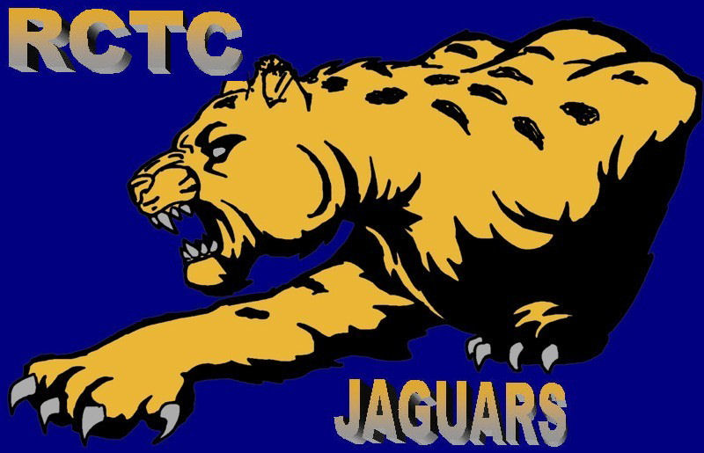

Day 1 it was HOT. We started off with the field events. Sania McGhee Shot Put 36-05.75(PR)(15th), Kyleigh Turks Shot Put 29-1.25(PR)(48th), Elijah Reams Discus 103-11(PR)(12th), Roland McGhee LJ 22-11(10th), and John Sherman LJ 21-0.75(35th)
On the track we had Ethan Rayes 3000m 11:30.86(PR)(10th), Kaylib Nelson 400mH 58.84 (13th), Mario Paul 400mH 54.03 qualified for the finals tomorrow. Spinnaker Rooley 800m 2:34.14(56th), Kyle Witherspoon 800m 2:07.32(34th), Isaiah Hickman 200m 28.30(29th) and Arianna Isabell 200m 27.07 qualified to the semi-finals on Wednesday. Congrats to all that competed today.

Day 2, another blazing hot day. We started off with the track events. Mario Paul 400mH 52.32(3rd) ALL-AMERICAN, Arianna Isbell 100m 12.78(PR) qualified to the semi-finals on Thursday, John Sherman 100m 10.90(50th), and Isaiah Hickman 100m 14.10(56th)
With the field events Cason Agnew discus 99-11(30th) Amira Maynard long jump 13.4.75(35th) and we finished it off with a National Champion Arianna Isbell is the 12yr old 2021 AAU Junior Olympic Games long jump Champ, with a jump of 16-1.75(PR) ALL-AMERICAN. Congratulations to all.

Day 3 we started with the distance races Miranda Howse 800m 3:26.19(59th) and Ethan Reyes 800m 2:47.06(56th). Arianna Isbell ran 200m prelims 26.63(PR)(17th) Then onto the hurdles with Robert Franklin III 80mH 16.50(PR)(25th), Kaylib Nelson 110mH 16.01(27th), and Mario Paul 110mH 14.59(17th) and we finished with Sania McGhee discus 50-03(62nd). Congratulations to all.

Day 4 we started with the 1500m Miranda Howse 6:41.01(41st) and Ethan Reyes 5:33.46(42nd), Arianna Isbell ran the 100m semi-finals 13.02(15th) and then we finished up with the 4x400 relays:
13-14; 4:04.56(29th) Wyatt Brown, Caleb Crawford, Elijah Reams, Spinnaker Rooley
15-16; 3:38.96 (26th) Kaylib Nelson, Gary Willis, Caleb Crawford, Justin Jefcoat
17-18; 3:20.27(15th) Naiden Maynard, John Sherman III, Roland Mcghee, Mario Paul
Congratulations to all.

Day 5, we started with Robert Franklin III turbo javelin 82-01(14th), then onto the track with the 400m Spinnaker Rooley 1:02.58(69th), Caleb Crawford 57.60(67th) and Mario Paul 49.74(28th)
Congratulations to all.

